

DUBLIN INSTITUTE OF TECHNOLOGY
_____________

DT228A/1 MSc in Computing
DT228B/1 MSc in Computing
DT228B/2 MSc in Computing
______________

SUPPLEMENTAL EXAMINATIONS 2017/2018
______________

Probability and Statistical Inference [Math9102]

Ms. Deirdre Lawless
Dr. Deirdre Lillis
Dr. Ignacio Castiñeiras

Date & Time TBA

Two Hours

Instructions to candidates

Answer question one and one other question.

All questions carry equal marks.

Description of Dataset to be used in All Questions

A researcher wants to investigate salaries and the nature of employment security in the ICT sector in Ireland.
They have collected a dataset comprising 52 cases, each representing a single employee, which was constructed by conducting a survey in the Grand Canal Dock area of Dublin, which has a high representation of ICT companies, on a single day. Their intention is to conduct a statistical analysis of this dataset so that they can extrapolate their findings to the ICT sector in general in Ireland. It is estimated that approximately 105,000 people are currently employed in the ICT sector in Ireland. The gender ratio in the ICT Sector in Ireland is 81:19. Missing data is not a concern.
The researcher has developed a theory as part of their research that there is a correlation between years of experience and salary earned, that there is a difference in salary based on gender and that there is a difference in salary based on the nature of employment (temporary, contract ,permanent).
Traditionally a 5% cut-off level of statistical significance is used within the research domain.
In addition, while conducting this survey the researcher asked a range of Likert style questions designed to assess an employee’s level of satisfaction with their employment. Their intention is to undertake a dimension reduction using the resulting variables to uncover latent variables.

Variables of concern in the dataset
Name | Label | Values | Type
salary | Annual Salary |  | Scale
gender | Gender | 1=Female, 2=Male | Nominal
empstatus | Employment Status | 1=Temporary, 2=Contract, 3=Permanent | Nominal
exper | Years of experience |  | Scale
Variables Related to Survey on Employee Satisfaction with their Employment
att_1 | Attitude: Work Environment | 1(Extremely Satisfied) to 10 (Extremely Dis-satisfied) | Nominal
att_2 | Attitude: Salary | 1(Extremely Satisfied) to 10 (Extremely Dis-satisfied) | Nominal
att_3 | Attitude: Support from Management | 1(Extremely Satisfied) to 10 (Extremely Dis-satisfied) | Nominal
att_4 | Attitude: Clarity of Responsibilities | 1(Extremely Satisfied) to 10 (Extremely Dis-satisfied) | Nominal
att_5 | Attitude: Work Hours | 1(Extremely Satisfied) to 10 (Extremely Dis-satisfied) | Nominal
att_6 | Attitude: Company to Work for | 1(Extremely Satisfied) to 10 (Extremely Dis-satisfied) | Nominal

1. | (a) | Explain the concepts of representativeness, Type I and Type II errors and how they are related.  In your answer you should clearly explain the concepts of statistical significance and statistical power and how they are related to Type I and Type II errors  (10 marks)
 | (b) | Using the information provided in the descriptor on the previous page and the descriptive statistics in Appendix A.  Briefly discuss the suitability of the dataset collected for use in the proposed research.  Comment in particular on the representativeness of the sample and consider the potential for the occurrence of Type I and Type II errors and explain clearly how you would address any issues you identify.  (10 marks)
 | (c) | - Explain the steps that you would need to take to develop and test hypotheses related to this theory.  Illustrate your answer by deriving and stating hypotheses related to the researcher’s theory using the statistics provided in in Appendix A.  (10 marks)  - Select and interpret the appropriate statistical test to test your hypotheses reporting your statistics according to APA guidelines.  Justify your selection based on your analysis of the descriptive statistics provided in Appendix A.  (15 marks)
 | (d) | Suppose the researcher extended their theory and proposes that a respondent’s employment status differs based on gender.  State clearly what type of statistical test could be used to test a related hypothesis and explain how this test works.  (5 marks)

2. | (a) | The researcher decided to build an inferential model to further explore the relationship between salary, experience and gender. They have created standardised scores for salary and years of experience. A dummy variable for gender dummyGender which has a value 0 for male and 1 for female has also been included.  The researcher first created a simple linear regression model including the standardised score for the years of experience and gender as predictor variables for the standardised score for salary.  - Explain what multiple linear regression will allow the researcher to do and what in this context prediction means.  (5 marks)  - Explain clearly why a dummy variable is needed for gender and what it will allow the researcher to explore.  (6 marks)
 | (b) | Using the statistics provided in Appendix B:  - State the regression equation;  - Interpret the model for male and female respondents;  - Assess the fit and usefulness of the model considering the coefficients, r², adjusted r²and f statistic;  - Report the relevant statistics according to APA guidelines;  - Explain the concepts you use to assess the fit and usefulness of the model.  (30 marks)
 | (c) | Two major concerns for multiple linear regression are multicollinearity and outliers.  Explain these concerns and why they are important and what can be done to address these concerns.  Illustrate your answer by assessing these concerns for the model created in part (a) referring to the information provided in Appendix B.  (9 marks)

3. |  | As part of their survey the researcher has collected data on employee satisfaction with their employment. They conducted a survey using an attitudinal scale (captured in variables att_1 to att_6). They wish to incorporate measures of employee satisfaction with their employment into inferential models without including all variables. They wish to conduct an exploratory factor analysis on these variables.  Explain clearly the objectives of exploratory factor analysis and principal component analysis, the difference between the two approaches and when you would use each technique.  (12 marks)
Explain how you would assess the suitability of a dataset and the reliability of a scale for use in exploratory factor analysis.
Explain any concepts you use within your analysis.
Illustrate your answer by assessing the dataset used by the researcher using the additional statistics and graphs provided in Appendix C.
(21 marks)
3. |  | Suppose the researcher conducted an Exploratory Factor Analysis on these variables using Principal Axis Factoring as the extraction method and Varimax as the rotation.  Explain how factor analysis works focusing on extraction and loading.  In your answer explain clearly the concept of a factor.  Illustrate your answer by interpreting the output of the factor analysis conducted for this research using the information provided in Appendix C.  (17 marks)

Descriptive Statistics
   |  | Years of experience | Annual salary in euros
  N | Valid | 52 | 52
  N | Missing | 0 | 0
  Mean |  | 16.12 | 23797.65
  Median |  | 15.50 | 23719.00
  Mode |  | 1ª | 28200
  Std. Deviation |  | 10.222 | 5917.289
  Variance |  | 104.496 | 35014310.937
  Skewness |  | 0.077 | 0.475
  Std. Error of Skewness |  | 0.330 | 0.330
  Kurtosis |  | -1.123 | -0.433
  Std. Error of Kurtosis |  | 0.650 | 0.650
  Range |  | 34 | 23045
  Percentiles | 25 | 6.25 | 18132.25
  Percentiles | 50 | 15.50 | 23719.00
  Percentiles | 75 | 23.75 | 27725.50
  a. Multiple modes exist. The smallest value is shown
  Employment Status
   |  | Frequency | Cumulative Percent
  Valid | Temporary | 18 | 34.6
  Valid | Contract | 14 | 26.9
  Valid | Permanent | 20 | 38.5
  Valid | Total | 52 | 100.0
  Gender
   |  | Frequency | Cumulative Percent
  Valid | Female | 14 | 26.9
  Valid | Male | 38 | 73.1
  Valid | Total | 52 | 100.0
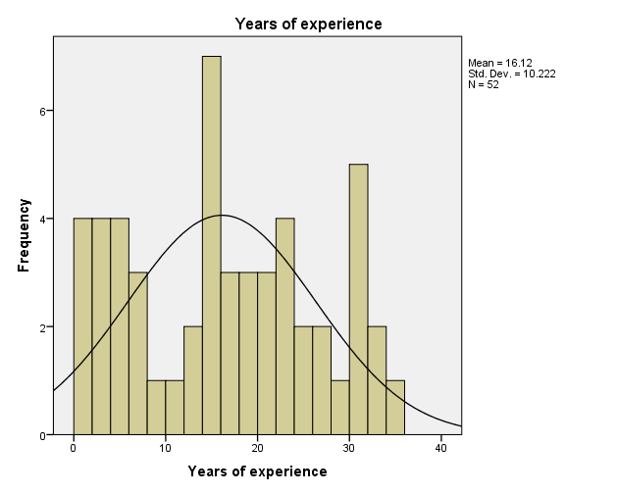 | 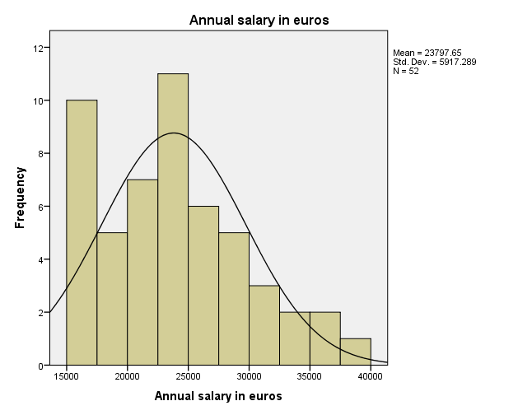

 | Mann-Whitney Test
  Correlations
   |  |  | Annual salary in euros
  Spearman's rho | Years of experience | Correlation Coefficient | .679**
  Spearman's rho | Years of experience | Sig. (2-tailed) | 0.000
  Spearman's rho | Years of experience | N | 52
  Pearson Correlation | Years of experience | Correlation Coefficient | .675**
   |  | Sig. (2-tailed) | 0.000
   |  | N | 52
  Ranks
  Gender |  | N | Mean Rank | Sum of Ranks
  Years of experience | Female | 14 | 24.14 | 338.00
  Years of experience | Male | 38 | 27.37 | 1040.00
  Years of experience | Total | 52
  Annual salary in euros | Female | 14 | 19.50 | 273.00
  Annual salary in euros | Male | 38 | 29.08 | 1105.00
  Annual salary in euros | Total | 52
  Test Statisticsª
   | Years of experience | Annual salary in euros
  Mann-Whitney U | 233.000 | 168.000
  Wilcoxon W | 338.000 | 273.000
  Z | -0.681 | -2.022
  Asymp. Sig. (2-tailed) | 0.496 | 0.043
  a. Grouping Variable: Gender
Independent Samples Test (Grouping Variable Gender)
 |  | Levene's Test for Equality of Variances |  | t-test for Equality of Means
 |  | F | Sig. | t | df | Sig. (2-tailed) | Mean Difference | Std. Error Difference | 95% Confidence Interval of the Difference
 |  |  |  |  |  |  |  |  | Lower | Upper
Years of experience | Equal variances assumed | 2.665 | 0.109 | -0.627 | 50 | 0.534 | -2.015 | 3.215 | -8.473 | 4.443
Years of experience | Equal variances not assumed |  |  | -0.553 | 18.874 | 0.587 | -2.015 | 3.644 | -9.645 | 5.615
Annual salary in euros | Equal variances assumed | 0.000 | 0.985 | -1.847 | 50 | 0.071 | -3339.647 | 1807.716 | -6970.550 | 291.257
Annual salary in euros | Equal variances not assumed |  |  | -1.774 | 21.591 | 0.090 | -3339.647 | 1882.087 | -7247.147 | 567.854

ANOVA
Annual salary in euros (grouped by employment status)
Mean SquareFSig.
Between GroupsSum of Squaresdf | 1346783799.891 | 2 | 673391899.945 | 75.171 | 0.000
Within Groups | 438946057.879 | 49 | 8958082.814
Total | 1785729857.769 | 51

Multiple Comparisons
Dependent Variable: Annual salary in euros
Tukey HSD
(I) Employment Status | (J) Employment Status | Mean Difference (I-J) | Std. Error | Sig. | 95% Confidence Interval
 |  |  |  |  | Lower Bound | Upper Bound
Temporary | Contract | -5407.262 | 1066.553 | 0.000 | -7985.04 | -2829.49
Temporary | Permanent | -11890.28 | 972.407 | 0.000 | -14240.52 | -9540.05
Contract | Temporary | 5407.262 | 1066.553 | 0.000 | 2829.49 | 7985.04
Contract | Permanent | -6483.021 | 1042.961 | 0.000 | -9003.78 | -3962.27
Permanent | Temporary | 11890.283 | 972.407 | 0.000 | 9540.05 | 14240.52
Permanent | Contract | 6483.021 | 1042.961 | 0.000 | 3962.27 | 9003.78

Kruskal Wallis Test
  Ranks
  Employment Status |  | N | Mean Rank
  Annual salary in euros | Temporary | 18 | 10.17
  Annual salary in euros | Contract | 14 | 25.29
  Annual salary in euros | Permanent | 20 | 42.05
  Annual salary in euros | Total | 52
  Test Statistics^{a,b}
   | Annual salary in euros
  Chi-Square | 42.057
  df | 2
  Asymp. Sig. | 0.000
  a. Kruskal Wallis Test
  b. Grouping Variable: Employment Status

  Model Summary^{b}
  Model | R | R Square | Adjusted R Square | Std. Error of the Estimate
  1 | .702ª | 0.493 | 0.472 | 0.72639108
  a. Predictors: (Constant), dummyGender, Zscore: Zscore: Years of experience
  b. Dependent Variable: Zscore: Zscore: Annual salary in euros
  ANOVAª
  Model |  | Sum of Squares | df | Mean Square | F | Sig.
  1 | Regression | 25.145 | 2 | 12.573 | 23.828 | .000^{b}
  1 | Residual | 25.855 | 49 | 0.528
  1 | Total | 51.000 | 51
  a. Dependent Variable: Zscore: Zscore: Annual salary in euros
  b. Predictors: (Constant), dummyGender, Zscore: Zscore: Years of experience
Coefficientsª
Model |  | Unstandardized Coefficients |  | Standardized Coefficients | t | Sig. | Collinearity Statistics
 |  | B | Std. Error | Beta | t | Sig. | Tolerance | VIF
1 | (Constant) | 0.117 | 0.118 |  | 0.992 | 0.326
1 | Zscore: Zscore: Years of experience | 0.658 | 0.102 | 0.658 | 6.440 | 0.000 | 0.992 | 1.008
1 | dummyGender | -0.435 | 0.228 | -0.195 | -1.907 | 0.062 | 0.992 | 1.008
a. Dependent Variable: Zscore: Zscore: Annual salary in euros

 |  | 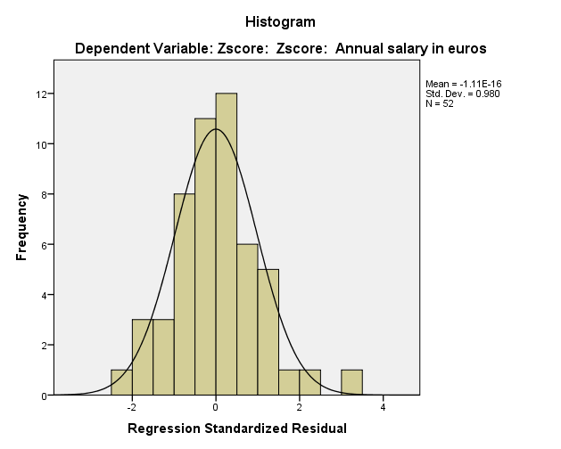
  Residuals Statisticsª
   | Minimum | Maximum | Mean | Std. Deviation | N
  Predicted Value | -1.2901621 | 1.3320054 | 0.0000000 | 0.70217372 | 52
  Residual | -1.62772846 | 2.21818662 | 0.00000000 | 0.71200567 | 52
  Std. Predicted Value | -1.837 | 1.897 | 0.000 | 1.000 | 52
  Std. Residual | -2.241 | 3.054 | 0.000 | 0.980 | 52
  a. Dependent Variable: Zscore: Zscore: Annual salary in euros

KMO and Bartlett's Test
  Kaiser-Mayer-Olkin Measure of Sampling Adequacy
  0.723Bartlett's Test of Sphericity Approx Chi-Square | 289.599
  df | 15
  Sig. | 0
  Correlation Matrix
   |  | Attitude: Work Environment | Attitude: Salary | Attitude: Support from Management | Attitude: Clarity of Responsibilities | Attitude: Work Hours | Attitude: Company to Work for
  Correlation | Attitude: Work Environment | 1 | 0.22 | 0.324 | 0.129 | 0.247 | 0.05
   | Attitude: Salary | 0.22 | 1 | 0.514 | 0.348 | 0.364 | 0.551
   | Attitude: Support from Management | 0.324 | 0.514 | 1 | 0.269 | 0.435 | 0.448
   | Attitude: Clarity of Responsibilities | 0.129 | 0.348 | 0.269 | 1 | 0.557 | 0.294
   | Attitude: Work Hours | 0.247 | 0.364 | 0.435 | 0.557 | 1 | 0.464
   | Attitude: Company to Work for | 0.05 | 0.551 | 0.448 | 0.294 | 0.464 | 1
  Determinant=.195
  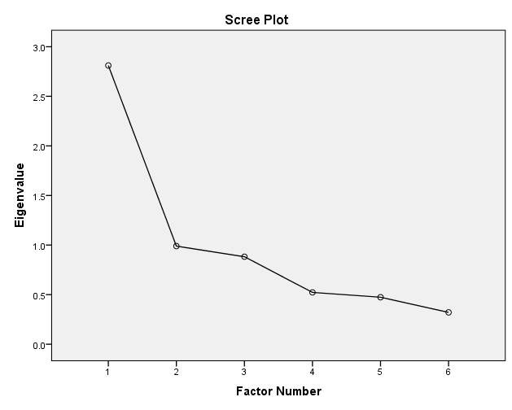
  Communalities
   | Initial | Extraction
  Attitude: Work Environment | 0.156 | 0.091
  Attitude: Salary | 0.425 | 0.48
  Attitude: Support from Management | 0.385 | 0.451
  Attitude: Clarity of Responsibilities | 0.338 | 0.289
  Attitude: Work Hours | 0.46 | 0.493
  Attitude: Company to Work for | 0.421 | 0.429
Factor Matrix
 | Factor
 | 1
Attitude: Work Environment | 0.702
Attitude: Salary | 0.693
Attitude: Support from Management | 0.672
Attitude: Clarity of Responsibilities | 0.655
Attitude: Work Hours | 0.537
Attitude: Company to Work for | 0.302

Total Variance Explained
 | Initial Eigenvalues |  |  | Extraction Sums of Squared Loadings
Factor | Total | % of Variance | Cumulative % | Total | % of Variance | Cumulative %
1 | 2.811 | 46.849 | 46.849 | 2.233 | 37.225 | 37.225
2 | 0.989 | 16.491 | 63.34
3 | 0.882 | 14.704 | 78.044
4 | 0.522 | 8.708 | 86.751
5 | 0.474 | 7.898 | 94.65
6 | 0.321 | 5.35 | 100

 | 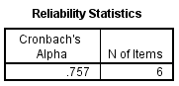
  Item-Total Statistics
   | Cronbach's Alpha if Item Deleted
  Attitude: Work Environment | 0.781
  Attitude: Salary | 0.692
  Attitude: Support from Management | 0.693
  Attitude: Clarity of Responsibilities | 0.74
  Attitude: Work Hours | 0.696
  Attitude: Company to Work for | 0.717

